Current Position The current X, Y and Z position in micro steps.

X and Y = 16000 micro-steps per inch.

Z = 128000 micro-steps per inch.

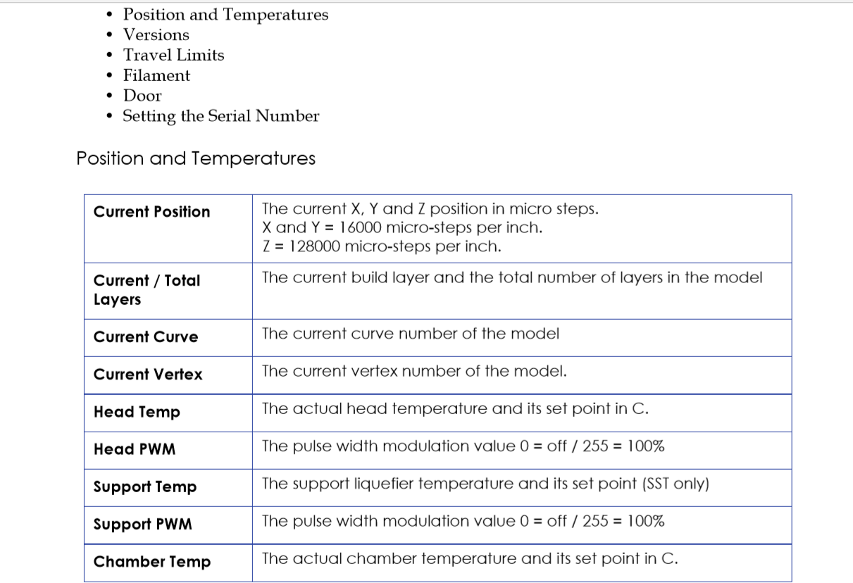

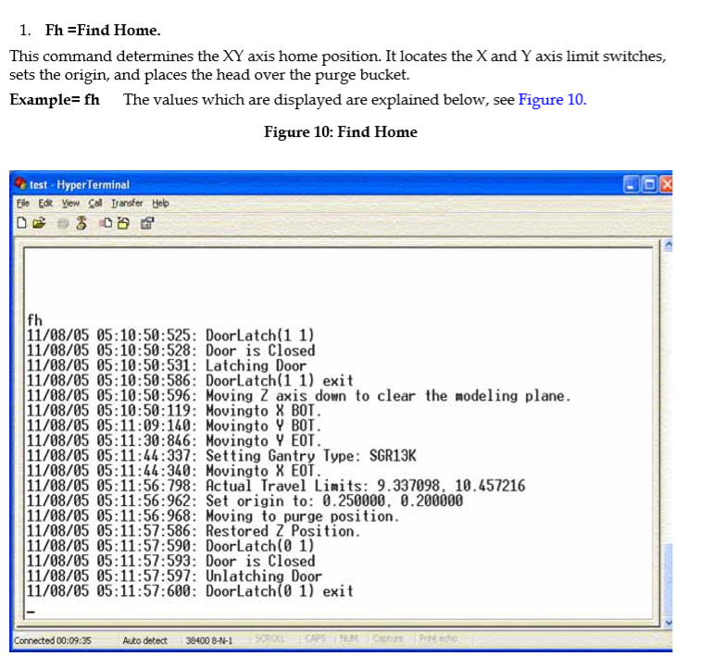

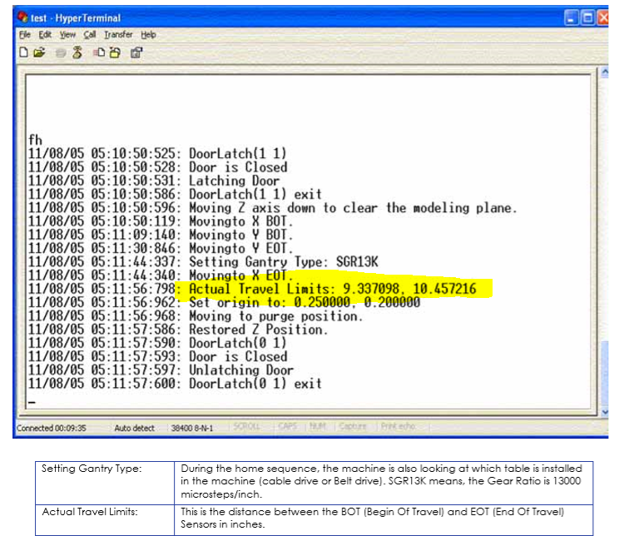

X:9.33 = 237.162mm Y: 10.45 = 265.613mm

Origin 6.35 mm 5.08

X EOT 9.337098   
Y EOT 10.457216

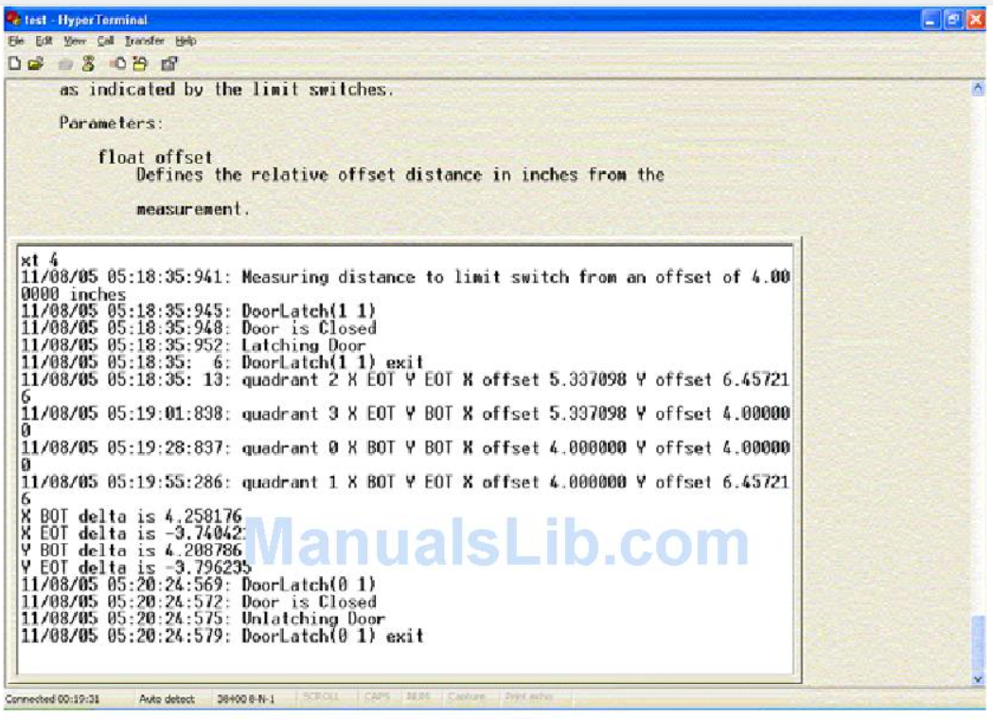

2 X offset 135.38  
0 X offset 101.6 Y offset 101.6

1 X offset 101.6 Y offset 164.0131

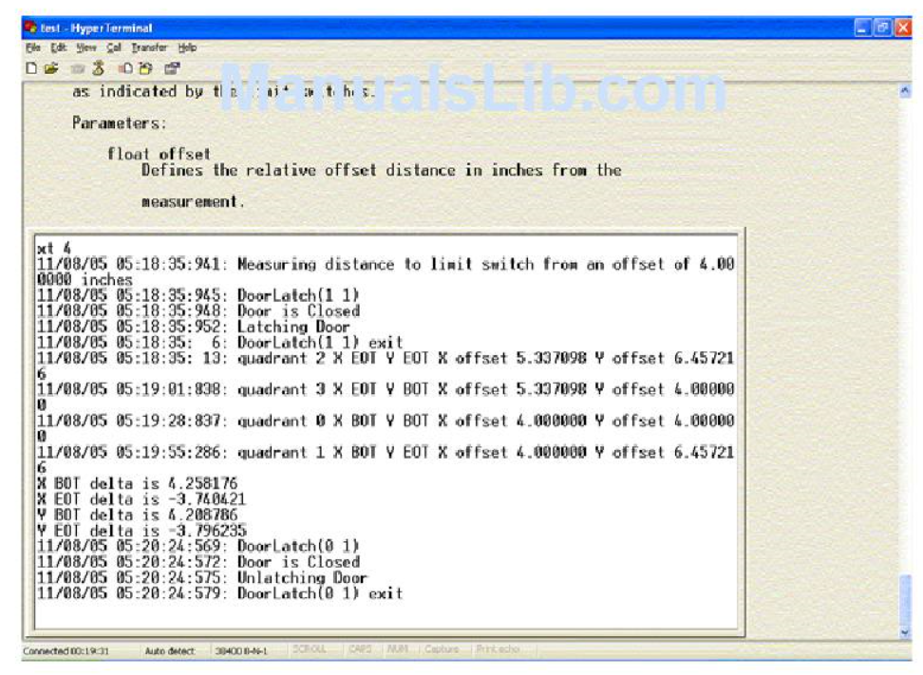

**5. xt=Test XY Limits**

Tests the XY axis by moving from corner to corner, stopping at each corner and measuring the offset against the actual position as indicated by the limit switches.

The command can be used for testing the Z-Stage. To do so, repeat the **tz** command at least 2 times and compare the **X BOT delta** values, **X EOT delta** values**, Y BOT delta** values and the **Y EOT delta** values. Parameters: Float Offset: Defines the relative offset distance in inches from the limit switch. The offset is the starting point for the measurement. **Example= xt 2.0** 2.0= distance, where the machine starts to look for the sensors. For repeating the command, type in the following: **rt 2 1 "xt 2.0”**. For more information see the rt command (item #8) in this manual.

Figure 13: Text XY limits

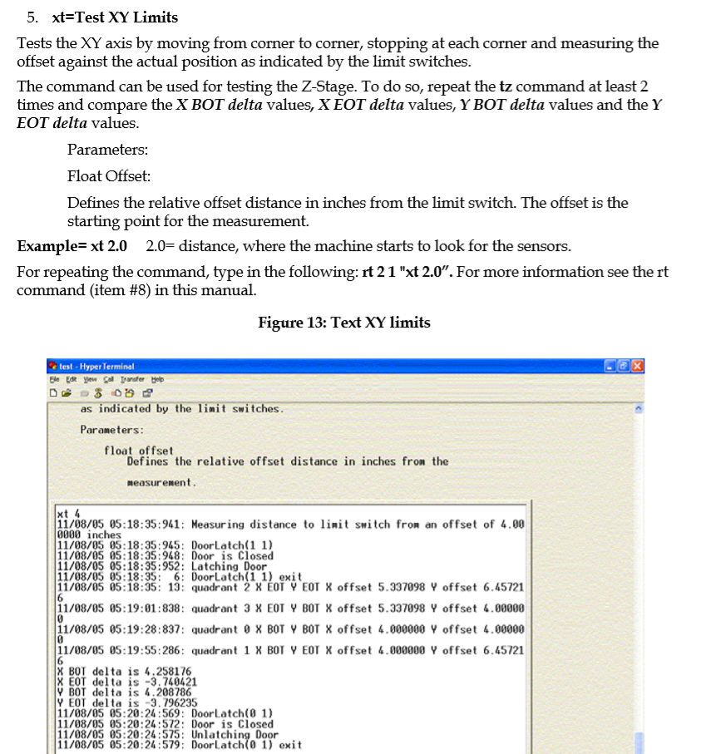

10. mx = move x This command moves the head in the X axis. Parameters: Float Position: This is the position it moves to, in inches, when the command is sent from the Console and in device units when the command is sent through the DPM.

Example: mx 3.0 (moves the X-Axis 3 inches away from the X-Home sensor

